Health-GPS: Weight - assignment, initialisation, and updates
Technical overview (code references: simulation.cpp, riskfactor.cpp, kevin_hall_model.cpp, static_linear_model.cpp, model_parser.cpp).
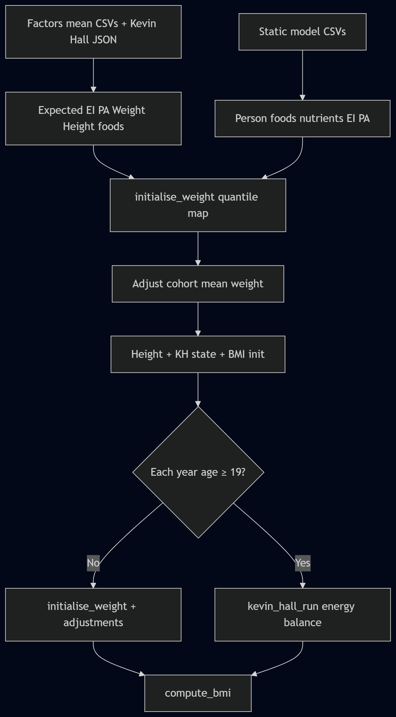
This note describes how body weight is represented, where it is initialised, how it changes each simulated year, and which configuration files and CSV inputs feed each step. In code, weight is stored on each person in risk_factors under the identifier Weight. BMI is derived from weight and height after those values are set.

Step-by-step walkthrough
Follow these steps in order. They match the code path for the usual setup (static linear model, then Kevin Hall dynamic model).

Part A — First simulated year (initialisation)
Step 1: Demographics — Simulation creates the virtual cohort and the demographic module assigns age, gender, region/ethnicity (if configured), etc. Weight is not set here.
Step 2: Socioeconomic (SES) — Income / SES is assigned. Used later as a covariate in static risk-factor regressions where configured.
Step 3: Static risk factor model runs — StaticLinearModel::generate_risk_factors assigns person-level inputs the dynamic model needs: food intakes, other nutrients as defined by the project, EnergyIntake, PhysicalActivity (simple or continuous), and any project-specific static factors. These values are stored on the person (risk_factors map and physical_activity where used).
Step 4: Dynamic model starts (KevinHallModel::generate_risk_factors) — For every person, nutrient intakes are derived from food intakes, then total EnergyIntake is recomputed from nutrients using the energy equation in the Kevin Hall JSON.
Step 5: First weight assignment (initialise_weight)
For each person the code:
(a) Reads expected energy intake and expected physical activity from the factors-mean tables (sex/age), with trend applied for EI.
(b) Forms expected E/PA = EI_expected / PA_expected.
(c) Forms actual E/PA from the person’s current EnergyIntake and PhysicalActivity.
(d) Computes ratio = (actual E/PA) / (expected E/PA).
(e) Maps that ratio onto a percentile using the sorted EnergyPhysicalActivityQuantiles CSV.
(f) Looks up the sex-specific WeightQuantiles vector at that percentile → w_quantile (a multiplier).
(g) Reads W_expected = get_expected(…, Weight, apply_trend=true) from factors mean.
(h) Sets person.Weight = W_expected × w_quantile.
Step 6: Cohort adjustment for Weight — adjust_risk_factors(…, Weight, …) shifts each person’s weight so the simulated cohort mean by sex/age matches the target mean implied by the expected table (after earlier steps).
Step 7: Height and Kevin Hall state — Mean weight raised to the height slope is taken by sex/age; height is initialised (expected height × weight effect × random residual). initialise_kevin_hall_state fills body compartments (fat, lean, glycogen, ECF, intercept K, energy expenditure) from current Weight, Height, PAL, EI.
Step 8: BMI — compute_bmi sets BMI = Weight / (height in m)².
After Part A, each person’s stored weight is: first the quantile-based draw (Step 5), then the same values after mean calibration (Step 6), which is what downstream height/KH state use.

Part B — Every later simulated year (update)
Step 9: Demographics, immigration, SES — Age increases; deaths/births and migration may change the roster. SES is updated.
Step 10: Static risk factor model update — Static factors (foods, policies, trends, etc.) are refreshed for the new year so EnergyIntake and PhysicalActivity (and foods) move forward.
Step 11: Dynamic model — newborns (age 0) — Nutrients and energy are initialised again; weight is set via the same initialise_weight logic as Step 5, then a newborn-specific mean adjustment; height and KH state are initialised for the newborn.
Step 12: Dynamic model — everyone else — Nutrients and energy intake are updated. If age < 19: initialise_weight runs again (same Steps 5a–5h with that year’s intakes). If age ≥ 19: kevin_hall_run advances compartments; weight becomes Weight = BodyFat + LeanTissue + Glycogen + water linked to glycogen + ExtracellularFluid. Baseline↔intervention scenarios exchange mean weight adjustments by sex/age; intervention applies adjust_weight or re-inits KH state for young ages. Height may still update for ages below the Kevin Hall adult threshold (19 in code).
Step 13: BMI again — compute_bmi runs for all active individuals.
Summary of what “weight” is after updates: for ages under 19 it is repeatedly the factors-mean-based quantile assignment (Step 5 formula), plus cohort and scenario adjustments; from age 19 onward it is the Kevin Hall energy-balance sum of compartments (Step 12), again after any cross-scenario adjustment.

1. Where weight lives in the simulation loop
Simulation.init → initialise_population()
Demographic → SES → Risk factor (static then dynamic) → Disease → Analysis
Simulation.update (each year) → update_population()
Demographic → immigration → SES → Risk factor update → Disease → Analysis
The risk factor host always runs the static model first, then the dynamic model on initialisation; on update it runs static then dynamic (see RiskFactorModule::initialise_population / update_population in riskfactor.cpp).

2. High-level weight pipeline

2.1 Initialisation (first simulated year)
[Static model] Generate individual intakes and covariates: food groups, nutrients, energy intake, physical activity, height inputs, etc. (model-specific CSVs + regression/policy tables).
[Dynamic — KevinHallModel::generate_risk_factors] For each person:
• initialise_nutrient_intakes / initialise_energy_intake (from current food → nutrient → energy).
• initialise_weight (see §3).
• adjust_risk_factors(…, {Weight}, …) to align cohort mean weight to expected means.
• Group mean weight^(height_slope) by sex/age → initialise_height → initialise_kevin_hall_state (body fat, lean, glycogen, ECF, intercept K, EE) → compute_bmi.

2.2 Annual update
[Static] update_risk_factors — refreshes static factors (e.g. foods, policies) for the year.
[Dynamic — KevinHallModel::update_risk_factors]
• Newborns (age 0): nutrient/energy/weight init, newborn weight adjustment, height + KH state.
• Non-newborns: update nutrients/energy; if age < 19 → initialise_weight else kevin_hall_run; baseline/intervention weight adjustments; adjust_weight / re-init KH state; update height for ages < 19.
• compute_bmi for all active persons.

3. How initial weight is set (initialise_weight)
File: kevin_hall_model.cpp, KevinHallModel::initialise_weight. The method builds a quantile-based draw that links individual energy balance posture to weight.
Expected EI = get_expected(…, EnergyIntake, apply_trend=true).
Expected PA = get_expected(…, PhysicalActivity, apply_trend=false).
Expected E/PA = EI_expected / PA_expected.
Actual E/PA = person EnergyIntake / person PhysicalActivity (after static + nutrient pipeline).
E/PA quantile ratio = (actual E/PA) / (expected E/PA).
Map ratio through sorted EnergyPhysicalActivityQuantiles → percentile.
Look up WeightQuantiles (sex-specific) at that percentile → multiplier w_quantile.
Expected weight = get_expected(…, Weight, apply_trend=true); person.Weight = expected_weight × w_quantile.
Expected values for Weight, EnergyIntake, PhysicalActivity, Height, and foods come from the male/female factors-mean CSV tables (see §5). Trended expectations for foods feed through nutrient and energy in get_expected; adult weight expectation can use an energy–PAL relationship (PAL from factors mean for PhysicalActivity in the current code path).

4. Kevin Hall dynamic update (age ≥ 19)
kevin_hall_age_min = 19. Below that age, weight is re-initialised with initialise_weight each year (with baseline↔intervention adjustments applied to align scenarios). From age 19 onward, kevin_hall_run integrates fat mass, lean tissue, glycogen-linked water, and extracellular fluid from prior state, carbohydrate and sodium dynamics, thermic/adaptive terms, and energy intake; then sets Weight = F + L + G + W_water + ECF.

4.1 Baseline vs intervention
compute_weight_adjustments compares simulated mean weight by sex/age to expected mean weight; the gap is sent over the scenario SyncChannel from baseline to intervention. Intervention receives adjustments and applies them via adjust_weight (scaling compartments) or re-initialises KH state for minors.

5. Data sources (what feeds weight)
Paths are typically relative to the simulation config root_path (from config.json).
Data / artefact | Role for weight | Loaded / used in code (indicative)
config.json — modelling.baseline_adjustment | Sex/age reference means for risk factors (Weight, Height, EnergyIntake, PhysicalActivity, foods, etc.). | model_parser.cpp load_risk_factor_expected() → CSV files factorsmean_male / factorsmean_female.
Dynamic model JSON (ModelName kevinhall) | Nutrient energy coefficients, nutrient ranges, food→nutrient matrix, food prices, trends; paths to weight quantile CSVs; E/PA quantile CSV; height std dev and slope. | load_kevinhall_risk_model_definition() in model_parser.cpp.
WeightQuantiles Female / Male CSV | Sorted list of weight multipliers (by E/PA percentile mapping). | KevinHallModel::get_weight_quantile.
EnergyPhysicalActivityQuantiles CSV | Sorted reference quantiles for energy/physical activity ratio. | Mapped to percentile for weight quantile lookup.
Static model JSON + CSV suite | Individual food intakes, optional two-stage models, physical activity (simple or continuous), policies, trends — supply person-level inputs before KH runs. | static_linear_model.cpp + model_parser staticlinear loader; registered via config risk_factor_models.static.
Repository / DataManager | Baseline tables and mappings used when parsing models and validating age coverage. | program.cpp loads config + data; CachedRepository registers model definitions.

6. BMI
KevinHallModel::compute_bmi: BMI = Weight / (Height_m)^2 with Height in metres (height stored in cm, divided by 100). Called for everyone after dynamic generate/update steps.

